LAB 1 - GOOGLE COLAB

De modificat doar Px si nr de la finalul .pdf

smx4=pd.read_csv("/content/drive/MyDrive/Colab_Notebooks/Log1-UPB-TEST-010-20190107.txt", delimiter = "\t")

with open('/content/drive/MyDrive/Colab_Notebooks/data_one_day.pickle', 'wb') as handle:

    pickle.dump(smx4, handle)

smx4

t = np.arange(0, 24, 1/3600)

P_smx4 = smx4['P']

P_smx4

U_smx4 = smx4['U1']

U_smx4

plt.figure(figsize=(12, 6)) # Optional: make the plot bigger

plt.plot(t, P_smx4)

plt.xlabel('Time [hours]')

plt.ylabel('Power P [watt]')

plt.title('Power vs Time')

plt.grid(True)

plt.show()

P_smx4.describe()

def p_medie(semnal, interval):

    n = len(semnal)

    media = np.zeros(n)  # Array to store the means, same size as input

    for i in range(0, n, interval):

        # Ensure we don't go out of bounds

        interval_mean = np.mean(semnal[i:i + interval])

        media[i:i + interval] = interval_mean

    return media

P4_1h_mean = p_medie(P_smx4, 3600)

plt.figure(figsize=(8, 2))

plt.xlim(0,25)

plt.plot(t, P4_1h_mean)

plt.xlabel('Time (hours)', fontsize=14, fontname='sans')

plt.xticks(fontsize=16)

plt.plot(t, P_smx4)

plt.savefig('/content/drive/MyDrive/Colab_Notebooks/Figures/figure.ending.in.07.pdf', format='pdf', dpi=1000)

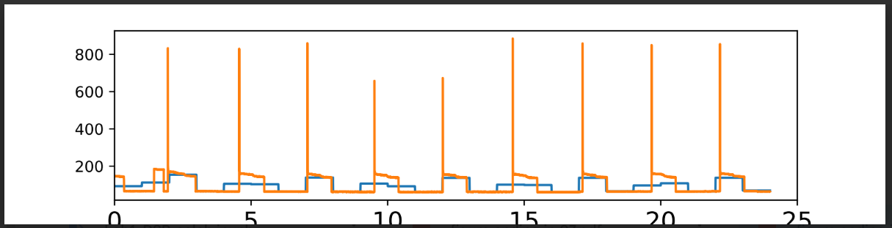

Figure ending in 4 & smx1

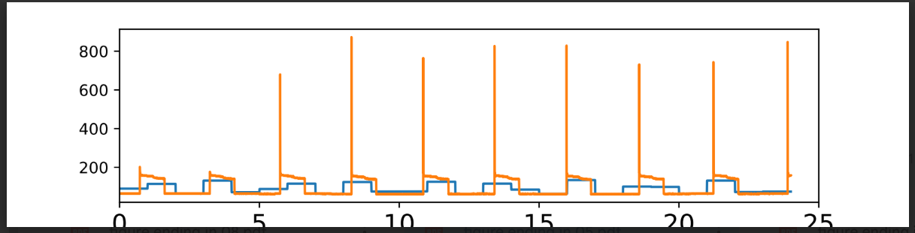

Figure ending in 5 & smx2

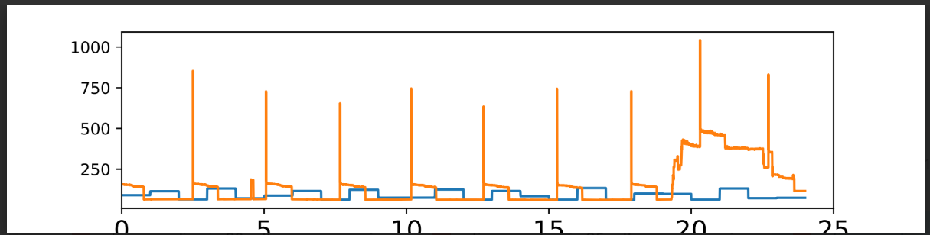

Figure ending in 6 & smx3

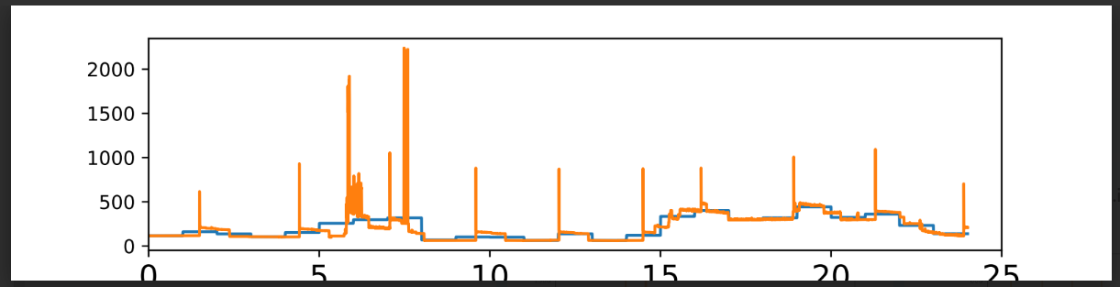

Figure ending in 7 & smx4

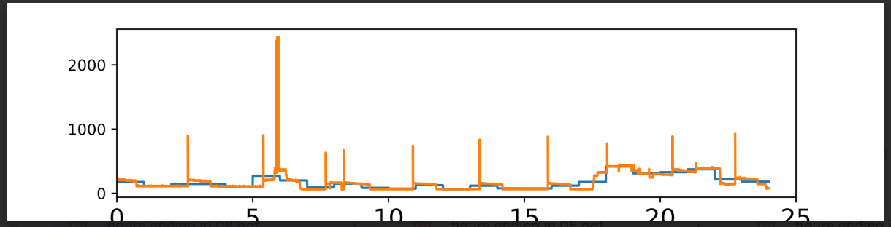

Figure ending in 8 & smx5

**Please import the files in the folder "date_panou_PQs) for the PMU and for the uPMU and create the average over 15-minute interval.** **-> create a time interval so you can create the plot P(t) and U(t)** **-> plot P(t) and U(t)** **-> save the plots and separte files**

from google.colab import drive

drive.mount('/content/drive')

from matplotlib import pyplot as plt

import numpy as np

import pandas as pd

import seaborn as sns

import os

from glob import glob

%matplotlib inline

folder_path = '/content/drive/MyDrive/Colab_Notebooks'

file_list = glob(folder_path + '/*.txt')

all_data = []

for file_path in file_list:

    try:

        df = pd.read_csv(file_path, delimiter='\t', low_memory=False)

        all_data.append(df)

    except Exception as e:

        print(f"Eroare la fișierul {file_path}: {e}")

df_all = pd.concat(all_data, ignore_index=True)

df_all['Timestamp'] = pd.date_range(start='2019-01-01', periods=len(df_all), freq='S')

df_all.set_index('Timestamp', inplace=True)

P_all = df_all['P']

U_all = df_all['U1']

df_15min = df_all[['P', 'U1']].resample('15T').mean()

plt.figure(figsize=(12, 4))

plt.plot(df_15min.index, df_15min['P'], label='Power P')

plt.xlabel('Time')

plt.ylabel('P [W]')

plt.title('P(t) - Power averaged over 15 minutes')

plt.grid(True)

plt.legend()

plt.savefig('/content/drive/MyDrive/Colab_Notebooks/Figures/P_15min_avg.png')

plt.figure(figsize=(12, 4))

plt.plot(df_15min.index, df_15min['U1'], label='Voltage U1', color='orange')

plt.xlabel('Time')

plt.ylabel('U1 [V]')

plt.title('U(t) - Voltage averaged over 15 minutes')

plt.grid(True)

plt.legend()

plt.savefig('/content/drive/MyDrive/Colab_Notebooks/Figures/U1_15min_avg.png')

